
Student Internship Program

Final Internship Report

Supervised By: Daw Lay Myat Myat Thein
DIR-ACE Technology Ltd. (DAT)

Internship Period:

May 4, 2026 – August 31, 2026

By

Hay Man Kyaw Min
ThaNaTa-1859

Software Engineering

Student Internship Program
University of Information Technology
Republic of the Union of Myanmar

2026 ~ 2027 Academic Year

Hay Man Kyaw Min ThaNaTa -1859

Software Engineering September, 2026

Table of Contents
Acknowledgement 3
Abstract 4
- Introduction 5
  - Introduction 5
  - Background and Organizational Structure of Host 5
  - Principal Activities of Host 6
  - Training Program 7
- Training Schedule and Assignments 8
  - Training Schedule by Month for Entire Period 8
  - Training Completed in 1st Month 9
  - Training Completed in 2nd Month 11
  - Training Completed in 3rd Month 15
  - Training Completed in 4th Month 16
- Knowledge and Experience Gained 20
  - Technical Knowledge Gained 20
  - Organizational Experience Gained 22
  - Relation of Internship to your Career Goals 24
- Conclusion 25
  - Summary 25
  - Benefit of Internship 25
  - Problems Faced 26
- References 28
- Appendices 29
Tables and Figures 30
Figures 30
Tables 30

Acknowledgement

The successful completion of my internship at DIR-ACE Technology Ltd. was made possible through the guidance, encouragement, and support of many individuals. First and foremost, I would like to express my sincere gratitude to Daw Thinn Thu Naing, Rector of the University of Information Technology (UIT), and Daw Than Than Nwe, Head of the Faculty of Information Science (FIS), for providing me with the opportunity to undertake this practical training and for their continuous academic support throughout my studies.
I would also like to express my heartfelt appreciation to my Academic Supervisor, Daw Lay Myat Myat Thein, for her valuable guidance, mentorship, constructive feedback, and advice throughout the preparation of this report. My sincere appreciation also goes to Daw Kalyar Soe, Managing Director of DIR-ACE Technology Ltd., for providing me with the opportunity to gain practical experience in a professional working environment, and to my Project Director, Daw Khine Thiri Win, for her guidance, encouragement, and continuous support throughout the project.
Furthermore, I am deeply grateful to my Company Supervisor, Daw Nyo Mon Naing Win, for her patience, guidance, and constructive feedback, which greatly contributed to the improvement of my technical knowledge and professional skills. Finally, I would like to thank all the members of my internship team at DIR-ACE Technology Ltd. for their cooperation, encouragement, and support. Their collaborative spirit and willingness to share their knowledge made my internship experience meaningful and valuable.

Abstract

This report provides an overview of my four-month internship as a Software Developer Intern at DIR-ACE Technology Ltd. (DAT), where I worked as a member of an intern team responsible for developing the DAT Employee & Courses Management System (ECMS). The system was developed to manage employee information, technical skills, courses, announcements, certificates, and examination dates. The frontend was developed using Next.js and TypeScript, while Spring Boot with Java was used for the backend, with MySQL serving as the primary database.
Throughout the internship, my main responsibility was backend development using Java, Spring Boot, Spring Security, and MySQL, including RESTful API development and database management. My contributions included designing database structures, implementing business logic and CRUD operations, and handling authentication, authorization, JWT, role-based access control, and data validation. I also participated in system testing, debugging and documentation while collaborating with team members using Git and GitHub. These experiences strengthened my skills in backend architecture, database management, API development, application security, testing, and collaborative software development.
The report also describes the host organization, internship training schedule, technical and organizational knowledge gained throughout the training period, and my reflection on how the internship experience supports my career goals as a software developer.

- Introduction

Introduction

An internship is an important part of software engineering education because it provides an opportunity to apply academic knowledge in a professional environment. During my four-month internship, I worked as a Software Engineering Intern at DIR-ACE Technology Ltd. as part of a development team responsible for developing the DAT Employee & Courses Management System (ECMS). The system was developed as a web-based application to manage employee information, technical skills, courses, announcements, certificates, and examination-related activities.
My main responsibilities included system analysis, database design, backend development, security implementation, and testing. I worked with Spring Boot, Spring Security, MySQL, JWT, and Apache Maven to develop backend services, RESTful APIs, and authentication and authorization features. I also participated in database design, system testing, debugging, and maintenance, while collaborating with team members on system requirements and data relationships. Through this internship, I gained practical experience in backend development, database management, application security, testing, and collaborative software development.

Background and Organizational Structure of Host

DIR-ACE Technology Ltd. (DAT) is an information technology company established in 2013 as a joint venture between Daiwa Institute of Research (DIR) of Japan and ACE Data Systems of Myanmar. The company was founded with the primary objective of supporting the development and modernization of Myanmar’s capital market through reliable and secure IT systems. DAT operates through three main divisions: the System Development Division, which is responsible for application development, infrastructure and operations, and local IT projects; the Offshore Development Division, which provides software development services to overseas clients, primarily in Japan; and the Management Division, which manages HR and payroll, finance, the Project Management Office (PMO), and staff development. Each division is further structured into departments and teams, enabling DAT to efficiently manage a wide range of software projects. The overall organizational structure of the company is illustrated in Figure 1.

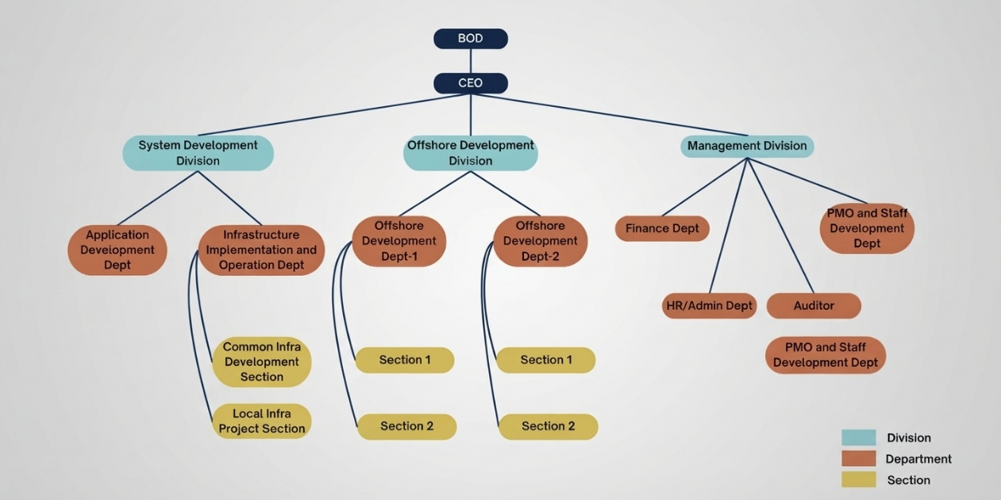

Figure 1: Organizational Structure of DAT

Principal Activities of Host

DIR-ACE Technology Ltd. (DAT) is an IT company established in 2013 as a joint venture to support the development of Myanmar’s capital market. Its core business focuses on providing IT support for systems used by stock exchanges and securities companies, with an emphasis on reliable, secure, and accurate mission-critical systems. DAT also provides software development, system integration, and IT services to local companies and Japanese corporations. Its offshore development division delivers system development services to the DIR Group and Japanese customers across distributed and host system environments, providing opportunities for international collaboration and exposure to global development practices. Through these activities, DAT serves Myanmar’s financial industry as well as the international offshore software development market, while continuing to expand its technical expertise, client base, and services.

Training Program

The internship program at DIR-ACE Technology Ltd. (DAT) was organized into three main phases over a four-month period, with the aim of preparing interns for practical project work.

Phase 1: Foundation and Skill Development – This phase focused on relearning and strengthening the technical skills required for the project, including Next.js, TypeScript, Java, Spring Boot, Git, and GitHub.

Phase 2: Project Development – During this phase, the intern team worked on the DAT Employee & Courses Management System (ECMS). I was assigned to backend development tasks, including Authentication, API integration, and Documentation and Database Design with each module having specific tasks and deadlines.

Phase 3: Documentation and Maintenance – The final phase involved assisting with the testing, resolving issues, and preparing documentation.

- Training Schedule and Assignments

Training Schedule by Month for Entire Period

Duration | Task Name | Task
1st Month – May 2026 | Backend Development & Database Fundamentals | Learned Java, Spring Boot, Spring MVC, Spring Data JPA, and MySQL fundamentals. Studied backend application structure, RESTful APIs, database design, entity relationships, and basic software development practices.
2nd Month – June 2026 | System Development | Studied the company project, system workflows, and database structure, and started contributing to the DAT Courses Management System. Developed backend services, implemented database operations and business logic, and worked on APIs based on the system requirements.
3rd Month – July 2026 | System Integration, Testing & Feature Development | Continued developing the DAT Courses Management System by implementing features for employee, course, attendance, progress, certificates, notifications, feedback, and reporting, while participating in testing and debugging.
4th Month – August 2026 | Maintenance & Enhancement | Worked on system maintenance and feature enhancements, improving self-study, employee information, feedback, announcements, reporting, attendance, and data integrity. Participated in final testing.
Table 1: Training Schedule by Month for Entire Period

Training Completed in 1st Month

The first month of the internship focused on building the technical foundation required for the ECMS project. The training covered programming, web development, backend technologies, security, reporting, version control, and project requirements through lessons, exercises, and presentations.

Object-Oriented Programming (OOP)
The training began with a revision of OOP concepts, including classes and objects, inheritance, encapsulation, polymorphism, abstraction, constructors, and method overriding. Practical assignments were provided to strengthen programming skills and prepare for Java-based development.

HTML, CSS, JavaScript and Bootstrap
HTML, CSS, and JavaScript were reviewed for web page structure, styling, and interactive behavior. Bootstrap was also studied for responsive layouts and reusable UI components. Practical exercises helped reinforce these web development fundamentals.

Spring Boot and Spring Security
Spring Boot was studied for RESTful API development, application structure, and HTTP request handling. A group presentation was also conducted to review Spring Boot concepts. Spring Security was introduced to understand authentication, authorization, and access control for secure applications.

Lombok and Jasper Report
Lombok was studied to reduce repetitive code in Java applications through annotations such as constructors, getters, and setters. Jasper Report was introduced to understand report templates, data sources, and generating structured reports from application data.

Git and GitHub
Git and GitHub were studied as part of the collaborative development workflow, covering repositories, branches, commits, and shared source code. These skills were important for working effectively with the development team.

Next.js and TypeScript
Next.js and TypeScript were reviewed as the main frontend technologies used in the ECMS. The training covered component-based development, routing, reusable components, types, and interfaces to prepare for frontend implementation and API integration.

Requirements Document
The Requirements Document (RD) was reviewed to understand the project's objectives, requirements, user roles, and expected features. This helped connect the technologies learned during training with the actual requirements of the ECMS.

Overall, the first month provided the technical and collaborative foundation needed for the project and prepared me for the development activities that followed.

Training Completed in 2nd Month

The second month marked the transition from foundational training to practical project development. The main focus was on understanding the project requirements, developing system features, implementing backend services, integrating APIs, and working collaboratively with the development team. The work progressed through four weeks, beginning with project setup and requirement analysis, followed by backend and database development, API implementation and security, and finally system integration and testing.

First Week – Project Structure and Setup
The first week focused on establishing the backend project structure and development environment. Since the ECMS backend was developed from scratch, we organized it using a standard Maven and Spring Boot structure, with separate packages for controllers, services, repositories, entities, and DTOs. This layered architecture helped maintain consistency, separation of concerns, and effective collaboration among team members.

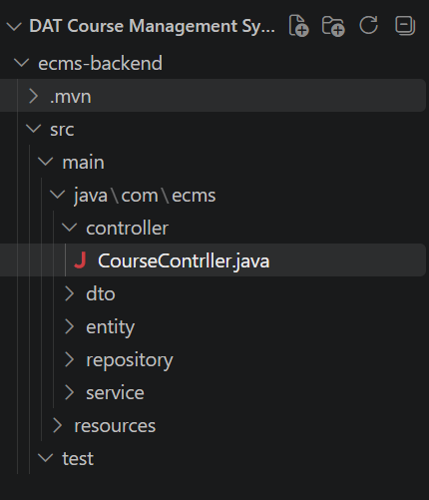

Figure 2: Top-Level Project Structure

Second Week – Backend API and Database Development
During the second week, I focused on backend development and database-related tasks for the ECMS. I worked on developing RESTful APIs using Spring Boot and connecting the application with MySQL. I also worked with the controller, service, and repository layers to organize backend functionality and manage data operations. In addition, I reviewed the database relationships and implemented required data-handling functions based on the system requirements. These activities helped establish the backend foundation required for integrating the frontend with the system APIs.

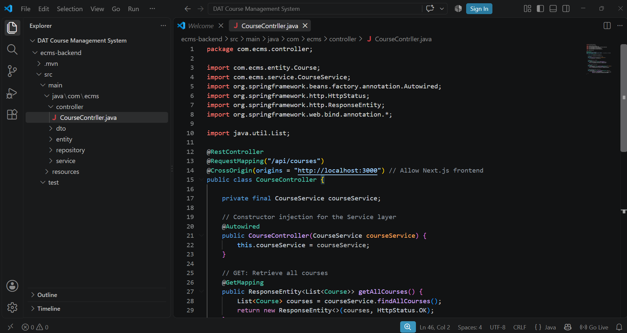

Figure 3: Backend Implementation

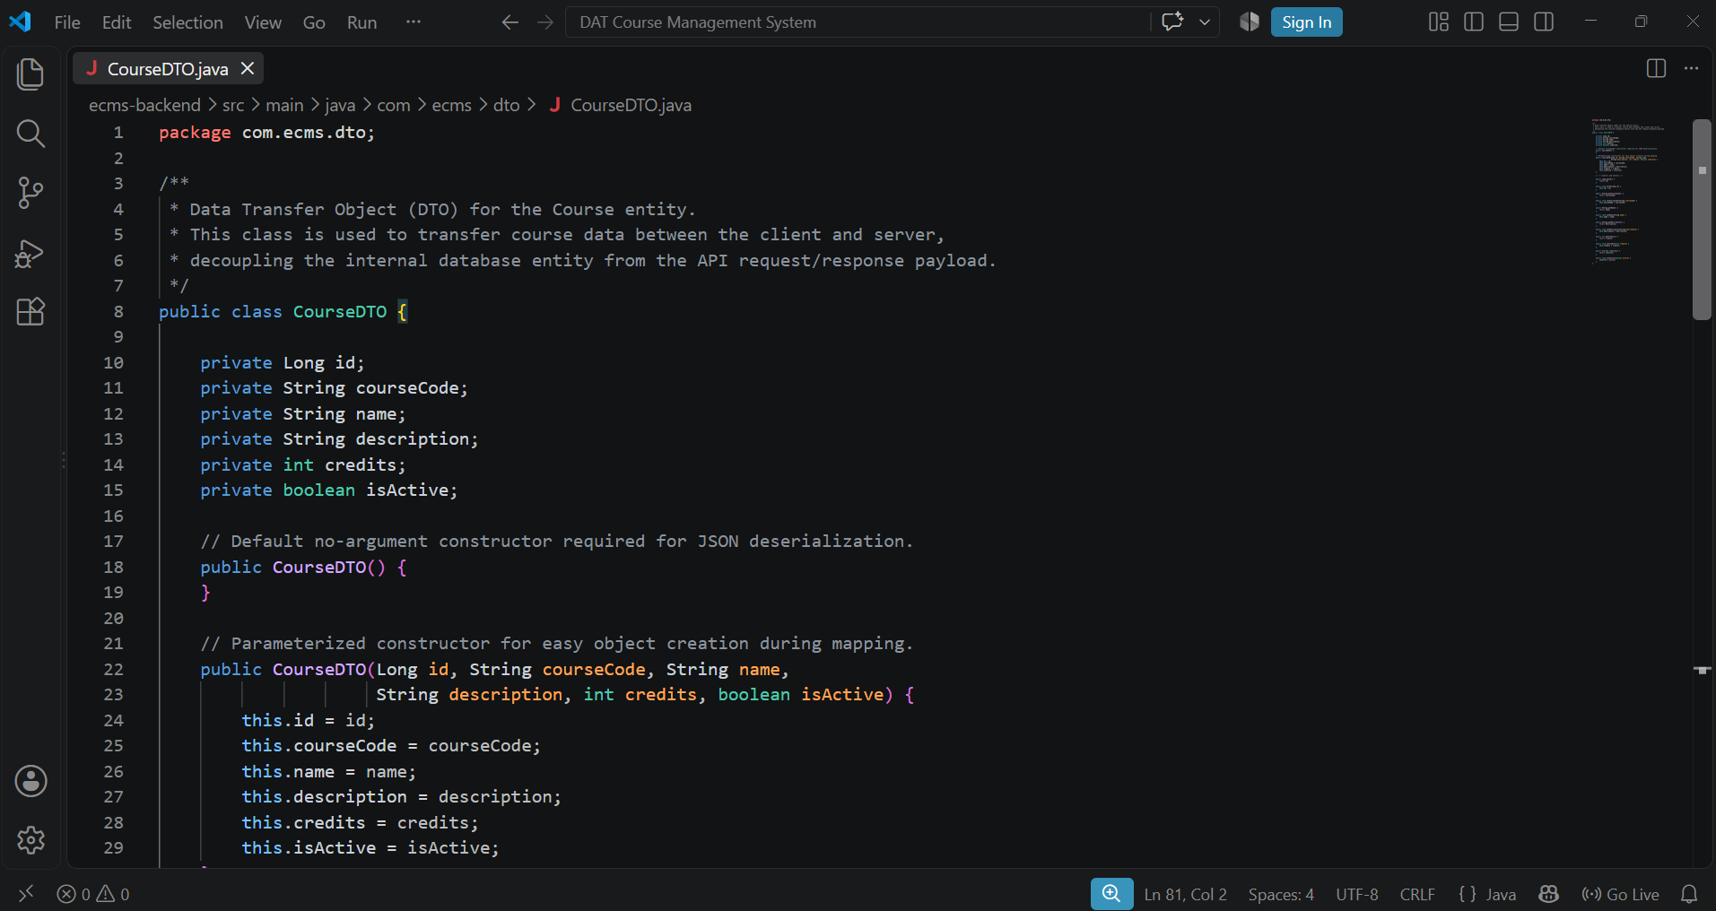
Figure 4: DTO Implementation

During the third week, I focused on backend development for the employee, holiday, target level, and skillset modules. I implemented REST APIs and business logic for CRUD operations, analyzed database relationships and system requirements. I also coordinated with the frontend team on API requests, responses, and JSON formats to support smooth system integration.

Documentation for Test Cases

Between the third and fourth weeks, I focused on testing documentation during the integration process. I tested the implemented features and APIs to identify functional issues, verified data flow and system behavior, and reported errors for correction. I also prepared and updated technical documentation based on the implemented features and testing results. These activities helped improve system reliability, maintain accurate project documentation, and ensure that the developed features met the required specifications.

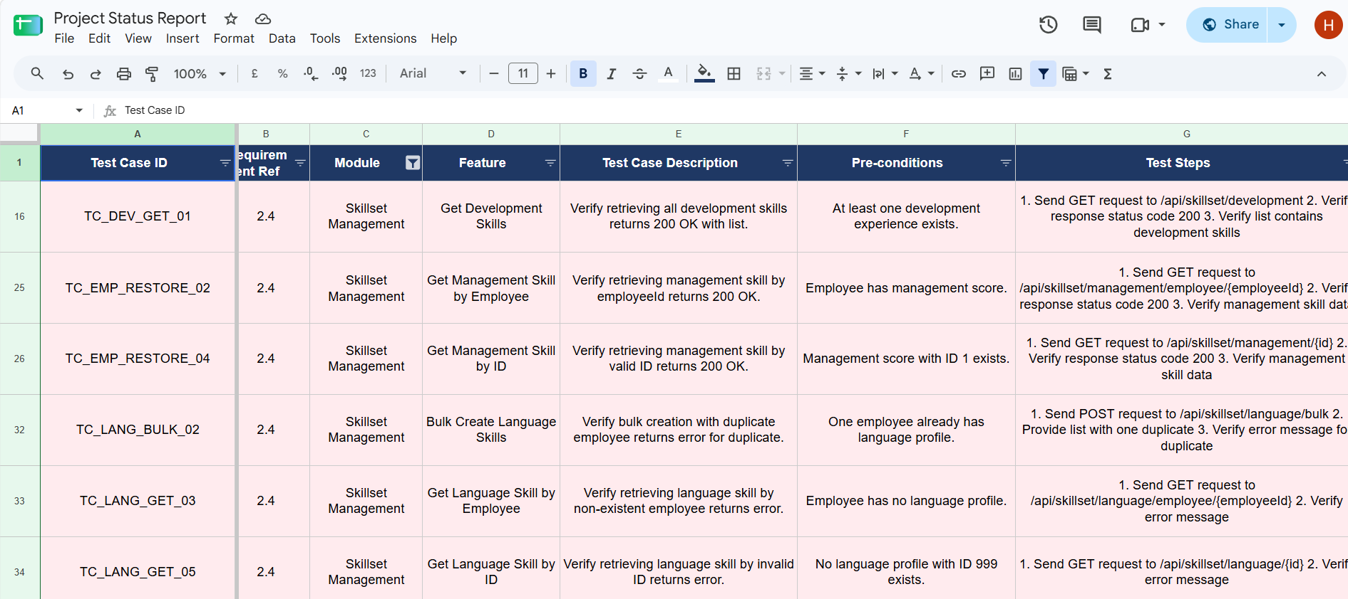

Figure 5: Test Cases Documentation

Training Completed in 3rd Month

The third month focused on backend feature development, API implementation, database operations, system testing, and integration of the main modules. The work was carried out over four weeks, covering module development, security, data processing, testing, and preparation for the project presentation.

First Week – Backend Module Development
During the first week, I focused on developing backend functionality for the employee, holiday, target level, and skillset modules. I implemented RESTful APIs and business logic for CRUD operations and worked with the database to manage the required data. I also reviewed the relationships between different entities to ensure that the backend functions correctly supported the system requirements.

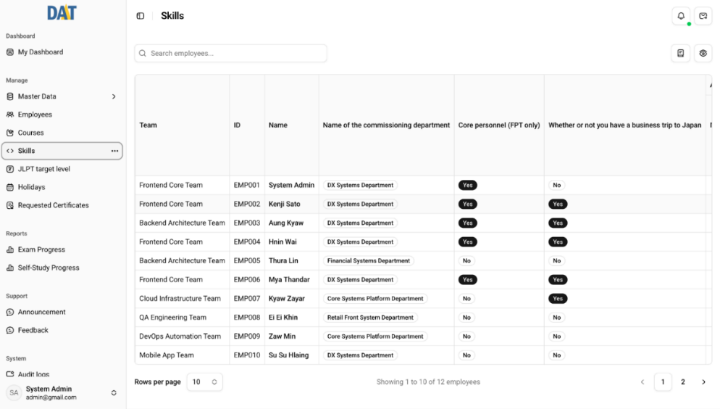

Figure 6 – Employee Skills and Assignment Matrix Interface

Second Week – API, Security, Data Management
In the second week, I continued developing and integrating backend APIs for the main system modules. I worked on data validation, exception handling, and database operations to ensure reliable data processing. I also implemented and reviewed authentication, authorization, and role-based access control using Spring Security and JWT to protect system resources according to user permissions.

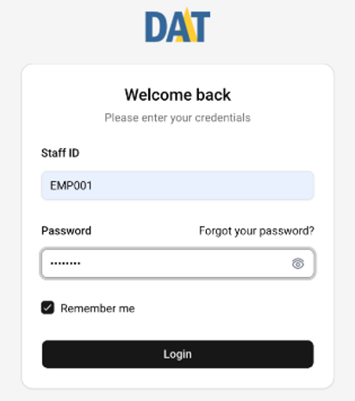

Figure 7 – User Authentication Interface

Third Week – System Testing and Debugging

The third week focused on testing the implemented backend functions and APIs. I tested CRUD operations, data validation, authentication, authorization, and API responses to identify functional and integration issues. I analyzed errors, worked with team members to resolve problems, and retested the affected functions to ensure that the implemented features worked correctly.

Fourth Week – Integration

In the fourth week, I participated in final system integration before the project presentation to the Project Management Office (PMO). I verified the main backend functions and data flow against the Requirements Document and helped identify and resolve remaining issues. I also prepared and updated API and technical documentation based on the implemented features.
Overall, the third month provided practical experience in backend development, database management, application security, API testing, debugging, and system integration. It also improved my understanding of how backend components support the complete functionality of a real-world software system.

Training Completed in 4th Month

The fourth month focused on final system adjustments, testing, documentation, and deployment preparation. The work was carried out over four weeks, covering requirement-based changes, system testing, issue resolution, documentation, and preparation for deployment to the company’s remote server.

First Week – Final Adjustment and Testing
During the first week, I worked on final adjustments based on feedback received after the project presentation. I reviewed the implemented backend features and APIs to ensure that they met the updated requirements. I also tested different modules and data flows to identify functional issues and inconsistencies. The identified issues were analyzed and reported for correction, helping improve the reliability and stability of the system.
In addition, I verified database operations and API responses to ensure that data was processed and returned correctly. These activities provided practical experience in validating system functionality and resolving issues during the final development stage.

Second Week – System Integration and Testing
In the second week, I focused on testing the integrated system after the frontend and backend components were connected. I tested RESTful APIs, CRUD operations, data validation, authentication, and authorization to verify that the system behaved correctly under different conditions.
I also worked with team members to identify and resolve integration issues between the frontend, backend, and database. After corrections were made, I retested the affected features to confirm that the changes did not introduce new problems. This process improved my understanding of integration testing and the importance of verifying complete data flow across system components.

Third Week – Documentation and Manual Guidelines

The third week focused on preparing technical and user documentation for the completed system. I reviewed the implemented features and documented the necessary information to support future maintenance and system usage. I also prepared User Manual Guidelines describing the main system functions and the steps required for users to operate the system.
The documentation was prepared to make the system easier to understand and use for both users and future maintainers. This work strengthened my ability to explain technical functions clearly and highlighted the importance of documentation in maintaining a software system.

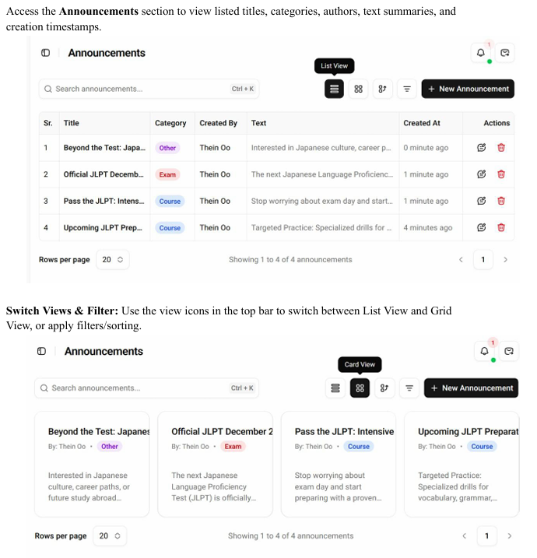

Figure 8: User Manual Guidelines Documentation

Fourth Week – Final Verification and Deployment

The fourth week focused on final verification and system refinement. I performed final testing of the system, reviewed previously identified issues, and verified that the required features were functioning correctly. I also reviewed and updated the documentation based on the final system functionality and testing results.

- Knowledge and Experience Gained

Technical Knowledge Gained

The internship provided practical experience with technologies and software development practices that cannot be fully learned through classroom study. Working on the ECMS allowed me to apply theoretical knowledge to a real-world system and understand how backend development, database design, security, testing, and deployment work together.

Backend Development with Spring Boot
I gained practical experience in developing backend services using Spring Boot. I learned how to structure applications using Controllers, Services, Repositories, Entities, and DTOs, and how these layers work together to process requests and manage business logic. I also developed RESTful APIs for different system modules and handled data operations through the backend.

Database Design and MySQL
I gained practical knowledge of relational database design using MySQL. I worked with tables, relationships, and data structures required by the system and learned how backend services interact with the database. This improved my understanding of data integrity, relationships, and efficient data management in a real-world application.

Spring Security and JWT
I gained practical experience in implementing application security using Spring Security and JWT. I learned how authentication and authorization work, how user roles are managed, and how access to system functions can be controlled based on user permissions. This helped me understand the importance of protecting backend APIs and application resources.

API Integration and Data Handling
Working with RESTful APIs helped me understand how requests and responses are handled between different parts of the system. I gained experience in designing API endpoints, processing JSON data, handling validation and errors, and ensuring that data was transferred correctly between the frontend, backend, and database.

System Testing and Debugging
I gained practical experience in testing system functions and APIs to identify functional and integration issues. I learned how to verify CRUD operations, validate data flow, reproduce errors, and retest functions after fixes. This improved my understanding of software quality and the importance of systematic testing before deployment.

Git and Collaborative Development
I used Git and GitHub as part of the development workflow. I learned how to manage source code, create commits, work with branches, and collaborate with team members. This provided practical experience in maintaining code and coordinating changes within a development team.

Organizational Experience Gained

Beyond technical knowledge, the internship provided valuable experience in working within a professional software development organization. Working with supervisors, developers, and other interns helped me understand how software projects are planned, developed, tested, documented, and delivered as a team.

Working in a Development Team
I learned how team members work together toward a shared software project. My responsibilities were mainly related to backend development, database management, testing, and documentation, which required coordination with other team members to ensure that different parts of the system worked together correctly.

Task Assignment and Deadline Management
Tasks were assigned with specific requirements and deadlines. I learned to organize my work, prioritize tasks, and complete assigned responsibilities within the planned schedule. This improved my time management and ability to report progress to supervisors.

Communication with Cross-Functional Teams
I regularly communicated with supervisors and team members to clarify requirements, discuss technical issues, and resolve integration problems. This improved my ability to explain technical problems clearly, ask appropriate questions, and work effectively with others.

Documentation and Knowledge Sharing
I prepared API documentation, technical documentation, and User Manual Guidelines based on the implemented system. These activities taught me the importance of clear documentation for communication, maintenance, and future development.

Git-Based Collaboration

Using Git and GitHub introduced me to collaborative version control practices. I learned how to manage source code, create commits and branches, and coordinate changes with other team members while maintaining the shared project.

Iterative Development Process
The project followed an iterative workflow in which requirements were reviewed, features were developed, tested, and improved based on feedback. This helped me understand that software development is a continuous process of development, testing, review, and refinement.

Adapting to Changes
The system requirements and features were adjusted based on feedback and project needs. I learned to adapt my implementation, update affected APIs or database functions, and retest the system after changes were made.

Responsibility and Ownership
Working on a real company project gave me a stronger sense of responsibility. I learned to take ownership of assigned tasks, test my work carefully, resolve issues, and complete tasks before handing them over to other team members.

Relation of Internship to your Career Goals

The internship played an important role in developing my understanding of professional software engineering and shaping my career direction. Before the internship, most of my software development experience came from academic projects. Working on the ECMS allowed me to apply this knowledge to a real organizational system.

Backend Development Foundation
The internship strengthened my backend development skills through practical work with Java, Spring Boot, Spring Security, RESTful APIs, and MySQL. I gained experience in developing backend services, implementing business logic, and managing data through a structured application architecture.

Database and System Understanding
Working with MySQL and backend services improved my understanding of relational databases, data relationships, and data flow within a software system. I learned how database design affects backend development and overall system functionality.

Security and API Development
Implementing authentication, authorization, JWT, and role-based access control gave me practical knowledge of application security. Developing and testing RESTful APIs also strengthened my understanding of how different system components communicate.

Testing and Software Quality
Participating in system testing, debugging, and final verification helped me understand the importance of software quality. I learned that professional development requires not only implementing features but also verifying their correctness, resolving issues, and ensuring system stability.

- Conclusion

Summary

This internship provided me with practical experience in software development as a Software Engineering Intern at DIR-ACE Technology Ltd. (DAT). As part of the intern development team, I contributed to the DAT Employee & Courses Management System (ECMS), mainly focusing on system analysis, database design, backend development, security implementation, RESTful API development, testing, and documentation.
The internship progressed through four months, beginning with technical training and project preparation, followed by backend and database development, API and security implementation, system testing, documentation, and final deployment preparation.
Through this experience, I strengthened my technical and organizational skills and gained a better understanding of how software systems are developed and maintained in a professional environment. The internship provided a valuable foundation for my future career in software engineering and IT.

Benefit of Internship

The internship provided significant benefits to my technical and professional development. I gained hands-on experience with technologies including Spring Boot, Spring Security, MySQL, REST APIs, JWT, Git, and Apache Maven. Working on a real system helped me understand that professional software development involves more than writing code; it also requires database design, security, testing, documentation, deployment, and teamwork.
Working on backend features and resolving integration issues improved my problem-solving skills, while communicating with supervisors and team members strengthened my professional communication and collaboration skills. Testing and documenting the system also helped me develop a greater understanding of software quality and maintainability.
Overall, the internship allowed me to apply academic knowledge to a real-world project and provided practical experience that will support my future career in software engineering and IT.

Problems Faced

During the internship, I faced several technical and organizational challenges that required problem-solving, testing, and coordination with the development team. Working through these challenges improved my technical knowledge and ability to adapt to real-world development conditions.

API Request and Response Issues
One challenge was dealing with differences between expected and actual API request and response formats. I had to analyze the data flow, identify the cause of the mismatch, and adjust the backend or API implementation accordingly. This taught me the importance of consistent API design and clear communication between development teams.

Database and Data Relationship Issues
Some features required careful analysis of database relationships and data dependencies. I had to review the existing database structure and understand how changes in one module could affect related data. This improved my understanding of relational database design and data integrity.

Testing and Integration Issues
During system integration and testing, I encountered issues related to API behavior, data processing, and communication between system components. I tested the affected functions, identified the causes of errors, and worked with team members to resolve and retest them. This strengthened my debugging and integration-testing skills.

Security and Access Control
Implementing authentication, authorization, and role-based access control required careful consideration of user permissions. I had to ensure that users could access only the functions allowed for their roles. This helped me better understand practical application security and access control.

Requirement Changes
The system requirements and features were updated based on project feedback. These changes required modifications to backend logic, APIs, or data handling. I learned to adapt to changing requirements while maintaining existing functionality and performing regression testing after changes.
Each of these challenges provided valuable practical experience in debugging, testing, communication, and problem-solving. They helped me understand how real-world software development requires continuous adaptation and careful coordination throughout the development lifecycle.

5. References

- DIR-ACE Technology Ltd. DAT Courses Management System Project Documentation and Project-Progress Records. Internal documentation used during the internship.
- DIR-ACE Technology Ltd. Company Overview and Services. Retrieved from https://www.diracetechnology.com

6. Appendices

This appendix presents the Employee Management Database Schema designed for the ECMS during the internship. The schema covers employee information, user roles, departments, teams, and organizational divisions, along with account security and notification-related data. The employees table is connected to the roles, department_dir, and teams tables to maintain user roles and organizational relationships. The schema was designed to maintain organized and consistent employee data and support efficient database operations. The overall structure of the Employee Management Database Schema is presented in Figure 9.

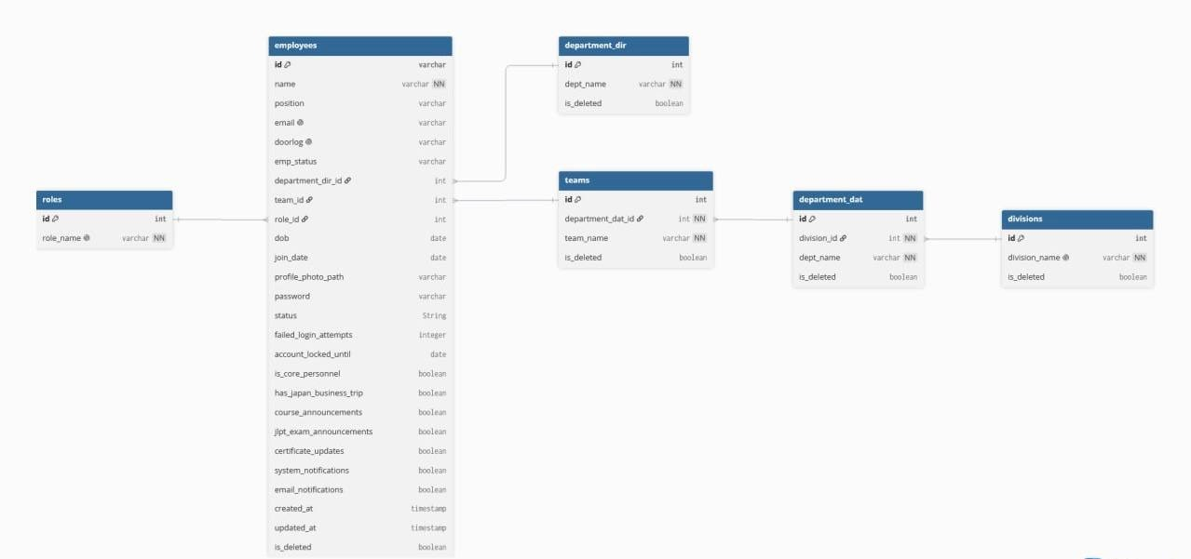

Figure 9 – Employee Management Database Schema

Tables and Figures

Figures
Figure 1 - Organizational Structure of DAT 6
Figure 2 - Top-Level Project Structure 11
Figure 3 - Backend Implementation 12
Figure 4 - DTO Implementation 13
Figure 5 - Test Cases Documentation 14
Figure 6 - Employee Skills and Assignment Matrix Interface 15
Figure 7 - User Authentication Interface 16
Figure 8 - User Manual Guidelines Documentation 19
Figure 9 - Employee Management Database Schema 29

Tables
Table 1 - Training Schedule by Month for Entire Period 8

